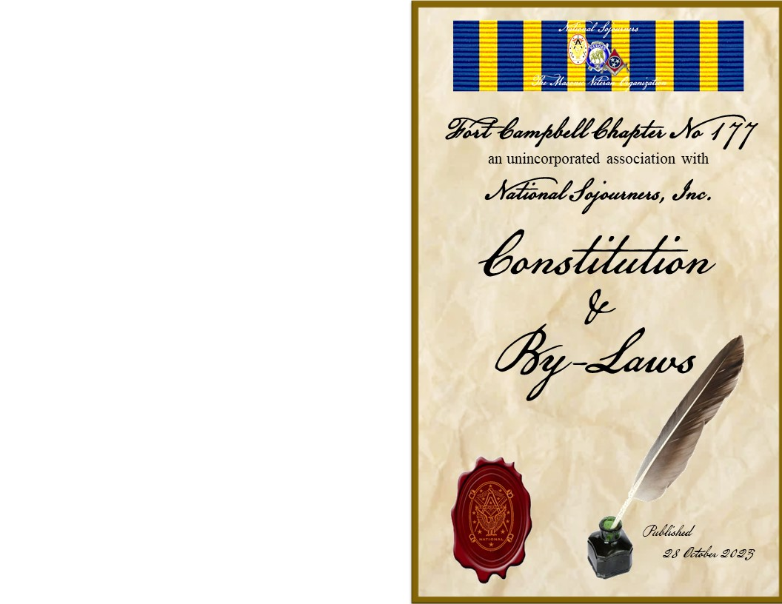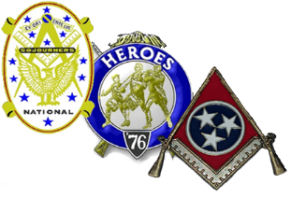
Fort Campbell Chapter No. 177
National Sojourners
By - Laws
an unincorporated association
with National Sojourners, Inc.

SECTION I
NAME

The name of this association shall be Fort Campbell Chapter No. 177, National Sojourners, Inc.

SECTION II
SUBORDINATE CHAPTER OF NATIONAL SOJOURNERS, INCORPORATED

1. This association is an integral subordination and constituent part of National Sojourners, Inc., a Virginia Non-profit Corporation. In case of any conflict between these By-Laws and the Articles of Incorporation, By-Laws, or National Directive of National Sojourners, Inc., the provisions of said-Corporation’s Articles of Incorporation, By-Laws and National Directives shall prevail.

2. This Chapter and its members are subject to not only these By-Laws, but also the Articles of Incorporation, By-Laws, and National Directives of National Sojourners, Inc. and the constitution, edicts and resolves of the Grand Lodge of the state in which a member affiliates, including any restrictions or prohibitions.

SECTION III
PURPOSES

The purposes of National Sojourners shall be to organize current and former members of the uniformed services of the United States (past and present) and Honorary Members, who are Master Masons, into Chapters for the promotion of good fellowship among its members, for assisting such as may be overtaken by adversity or affliction, for cultivating Masonic ideals, for supporting all patriotic aims and activities in Masonry, for developing true Patriotism and Americanism throughout the Nation, for bringing together representatives of the uniformed forces of the United States (past and present) in a united effort to further the military need of national defense, and for opposing any influence whatsoever calculated to weaken the national security.

SECTION IV
MEMBERSHIP

1. Membership in National Sojourners shall be open to:
a. Citizens of the United States who are Master Masons in good standing in any duly constituted Lodge of Master Masons including those Master Masons whose Grand Lodge is recognized by and maintaining fraternal relations with the Grand Lodge member of the Conference of Grand Masters of North America and within whose jurisdiction the prospective member’s chapter is located. Any question relating to eligibility for membership will be referred to the National Secretary by the most expeditious means for resolution.

b. Are serving or have served honorable as members of the uniformed services of the United States (past or present) or have served in a time of war in an armed service of a nation allied with the United States.

c. Master Masons who are not uniformed service veterans may be elected to honorary membership in the chapter in recognition of meritorious service to the nation and/or Masonry. The number of honorary members will be maintained in accordance with National Sojourners, Inc. directives.

2. There shall be four classes of membership as follows:
a. Active members: Those who are serving or have served honorably as members, regular or reserve, of the United States in the Army, Navy, Air Force, Marines, Coast Guard, Public Health Service, Oceanic and Atmospheric Service or predecessor services, or in the National Guard or Militia of the United States as defined in Title 10, US Code, Section 311, or have served in a time of war in an armed service of a nation allied with the United States.

b. Dual membership: A member of another Sojourner chapter, active or honorary, may become a dual member by election in this Chapter. A dual member will pay the full dues, including the national per capita tax. Dual honorary members will count against the 15% limit unless that honorary member is an elected Grand Lodge Officer (EGLO).

c. Multiple memberships: A member of another Sojourner chapter, active or honorary, may hold multiple memberships by election in this Chapter. Chapter dues will be paid: however, no national per capita tax shall be collected.

d. Honorary members: Those who are ineligible for active membership but who have been regularly elected honorary membership in this Chapter in recognition of meritorious service to the nation and/or Masonry. Honorably members, excluding Grand Masters, Past Grand Masters, Grand Secretaries and elected Grand Lodge Officers, may not exceed 15% of the chapter’s active membership.

3. All members shall have the same rights and privileges in this Chapter.

4. Persons qualified and desiring active membership in this Chapter shall make written application submitting the same to the Chairman of the Membership Committee. Within thirty days of receipt of the application, the Membership Committee must submit their recommendations to the Chapter at a regular meeting. At a subsequent meeting of the members the applicant may be elected to membership by a majority vote of those attending and voting. Payment of dues will not be made until after the applicant has been elected to membership.

5. Any member of this Chapter may recommend a person for honorary membership by submitting the person’s name and other pertinent information to the Membership Committee. Within a reasonable time thereafter, the Membership Committee will submit its recommendations to the members at a regular meeting. After such a recommendation has been submitted, the person so recommended for honorary membership may be elected to honorary membership by unanimous vote of those present and voting. Members are cautioned NOT to inform prospective honorary members that they are being considered for honorary membership. Once a person has been elected to honorary membership, the President or other member so appointed will inform the individual. Should an individual not be elected to honorary membership, nothing further needs to be accomplished and, since the individual will not have been informed or failing to be so elected, the Chapter will not suffer any embarrassment.

V
DUES

1. Regular Member Dues: At the October stated meeting the Chapter members shall determine the amount of Ft Campbell Chapter No 177 annual dues for the following year. The regular member annual dues (currently $10.00) shall be in addition to the National Sojourners, Inc. national per capita tax and initiation fees and cover the fiscal year from 1 January to 31 December.
2. Membership-in-Perpetuity (MIP): Any Sojourner in good standing in this Chapter or any other Chapter may become a Member-in-Perpetuity in this Chapter by making written application for the same, accompanied by the required National fee. Members-in-Perpetuity shall be exempt from paying all further dues.

3. In Memoriam Membership-in-Perpetuity: Deceased Master Masons who would have met the Chapter’s membership eligibility criteria may be granted In Memoriam Membership-in Perpetuity. Sponsors must make written application for the same accompanied by the required National fee. No further dues shall be required.
4. Prior to Jan 1st of each year the National Headquarters does an assessment of the paid up members listed on chapter roster. In anticipation of the 1 April deadline, members who have not paid their dues by the February meeting will have their names read during the meeting. Members who have not paid the required dues by 1 April will be dropped from the active membership roll. These members will be listed at the NSHQs as Non Paid Dues (NPD)-Inactive. Upon payment all rights and privileges of membership shall be reinstated.
VI
OFFICES

1. The elected officers of the chapter shall be:

a. President
b. 1st Vice President
c. 2nd Vice President
d. 3rd Vice President
e. Secretary
f. Treasurer
g. Marshall

2. The appointed officers of the chapter shall be:

a. Chaplain
b. Historian
c. Color Bearer

3. The term of office for all officers shall be for one year or until their successors have been elected and installed. Officers may succeed themselves in office. The office of the Secretary and Treasurer may be combined.

VII
DUTIES OF OFFICERS

1. The President shall be the Chief Executive Officer of the chapter and shall exercise overall supervision over all chapter affairs. He shall, when present, preside over all chapter meetings and shall be a member ex-officio of all committees except the Nominating Committee.

2. The 1st Vice President shall, in the absence or disability of the President, perform the duties of the President and when so acting shall have all the powers and shall be subject to all the restrictions upon the President. The 1st Vice President is normally the chairman of the Americanism Committee and J/ROTC Medals/Awards Program.

3. The 2nd Vice President shall, in the absence or disability of the 1st Vice President, perform the duties of the 1st Vice President. The 2nd Vice President normally shall be the chairman of the Bridge of Light Program Committee (i.e. programs that enhance coordination and communication with basic Blue Lodge and Appendant Body masonic organizations).

4. The 3rd Vice President shall, in the absence or disability of the 2nd Vice President, perform the duties of the 2nd Vice President. The 3rd Vice President normally shall be the chairman of the Membership Committee (i.e. applications, initiation).

5. Each Vice President shall be responsible for making a monthly report at each stated meeting for the committees they chair.

6. The Secretary shall keep a record of everything that needs to be written, prepare and publish chapter minutes, agendas, bulletins and maintain and publish a roster of members. He shall collect dues and turn over to the Treasurer, issue membership cards, give notice of special meetings, if any, and act as custodian of the chapter records.

7. The Treasurer shall maintain adequate and correct accounts of the properties and funds of the chapter including all receipts and disbursements. The Treasurer shall deposit all funds in the chapter account. The Treasurer may disburse chapter funds for the payment of all routine bills and statements received or as directed by the members and shall submit a monthly financial report to the chapter. The Treasurer shall receive recommendations from the Audit Committee and directions from the President to construct a financial budget for the chapter.

8. The Marshal shall verify members and guests that they sign the register and that they are properly introduced. He shall have custody of and maintain the chapter colors, Bible, charter and other items necessary to conduct the meeting. He shall act as cashier and collect fees for dinners, fines, or other charges incurred at chapter meetings, turning same over to the Treasurer.

9. The Chaplain shall conduct the devotional portion of the chapter meeting, give the Opening and Closing Prayers and in coordination with the President, render such aid and assistance to members and their families in times of sickness and distress as deemed advisable.

10. The Historian shall collect, compile and maintain the historical data pertaining to the chapter, submitting a report on the same from time to time, but as a minimum annually prior to the election of officers.

11. The Color Bearer shall maintain and post the Colors at all chapter meetings.

VIII
ELECTIONS

1. Annually, not less than two months prior to the annual meeting (April), the President shall appoint at least three PP/PC of the chapter/camp to act as the Nominating Committee to nominate officers to serve for the ensuing year.
2. The Nominating Committee shall choose its own chairman and shall submit its nominations, in writing, at the March meeting.

3. Election of officers shall be held during the April meeting. Nominations may be made from the floor; however, no nominees name may be submitted without such nominee’s prior consent. If there be more than one nominee for any office, a written ballot shall be cast.

4. The Nominating Committee shall conduct all elections.
5. Newly elected officers will be installed prior to the National Sojourners, Inc. Annual National Convention which is held in June.
IX
COMMITTEES

1. The chapter shall have the following Standing Committees and may have such other committees as the President may appoint:

a. Americanism Committee*
b. Bridge of Light Committee*
c. Education and Training Committee*
d. (J)ROTC Committee
e. Audit Committee
f. By-Laws Committee
g. Awards Committee
* Required by Paragraph 12.6, National By-Laws

2. The President shall appoint at least three members to each committee. The President shall also appoint the chairman of all committees, except the Nomination Committee. The duties of the committees shall be as follows:

3. The Americanism Committee shall formulate and direct a program to promote Americanism and Patriotism in the chapter and the surrounding communities IAW the National Directives.

4. The Bridge of Light (BOL) Committee shall formulate and direct the Bridge of Light Program to strengthen relationships between the chapter and the local Masonic Bodies with special emphasis on the Blue Lodges. It shall consist of sufficient number to enable a member to represent and maintain liaison with each of the following Masonic Lodges, namely all Masonic Lodges in District 7 of the Grand Lodge of Tennessee. (NOTE: Due to Chapter #177 proximity to the KY-TN state line, and no National Sojourner chapters in Kentucky closer than the Ft Knox area, attention should be given to KY Blue Lodges within a reasonable area.)

5. The Membership Committee shall be responsible for the operation of the Membership Program in accordance with National Directives. They shall receive all applications for membership, conduct investigations and make recommendations concerning any person whose name has been submitted to the committee for honorary membership. Recommendations concerning membership for other than honorary members shall be submitted to the chapter within thirty days of receipt of the application for membership. The committee shall also initiate and maintain a vigorous campaign for new members at all times.

6. The Nominating Committee shall perform the duties IAW Article VIII of these By-Laws.

7. The (J)ROTC Committee shall conduct, in conjunction with local schools (and/or colleges) with ROTC programs, a program for the presentation of the ROTC Awards.

8. The Audit Committee shall audit the reports of the Treasurer at the end of each fiscal year. The audit shall verify receipts, disbursements and bank balance on hand at the end of the fiscal year. The Audit Committee shall also prepare a report categorizing all income and expenditures for the year. The Audit Committee shall make recommendations to the President for the chapter's financial budget.

9. The By-Laws Committee shall receive, investigate and report to the chapter all recommendations for proposed changes to these By-Laws. Insofar as practical, reports and recommendations concerning proposed changes should be submitted to the chapter within thirty days of receipt.

10. The Awards Committee will:
- - distribute, receive, and process all National Sojourners Annual Essay Contest entries for submission to National Headquarters. This essay contest is open to students currently in the 9th to 12th grades, including home schooled students.

- - select the winner of the Ft Campbell Chapter #177 Essay Award to the student who submits the best entry for the high school National Essay.

- - receive, review and recommend awardees of the Gooch/Hodges Memorial Meritorious Service Award and Benny Deffendoll Distinguished Service Awards to the President of the chapter. See Sec XVII and Appendices.
X
MEETINGS

1. Regular Meetings shall be conducted on the 4th Saturday of each month except on national holidays. The chapter will be dark during the months of November and December unless called by a majority vote of the membership.

2. Annual Meetings shall be conducted on the 4th Saturday of April for the purpose of electing officers, assessing dues and such other business as may be necessary or desirable. A joint installation ceremony for Chapter #177 officers and Old Hickory Camp, Heroes of ’76 officers shall take place at this meeting.

3. Special Meetings may be held at any time at the call of the President or upon request by at least one-third of the members in writing, setting forth the purpose of the special meeting. No business may be conducted at such special meeting other than that specified in the notice calling for the special meeting. Written notice (which includes electronic messaging excluding text messages) must be given to all members at least ten days prior to all special meetings, which notice shall set forth the purpose for which the meeting is called.

XI
QUORUM AND VOTING

1. Five members of the chapter shall constitute a quorum for all meetings.

2. Every act or decision done or made by a majority of the members present and voting at a regularly scheduled or properly published special meeting at which a quorum is present, except an action to amend these By-Laws, shall be binding.

3. Voting shall be by ballot for chapter/camp officers unless motion is made to elect by acclamation. No proxies are permitted. Voting on business motions and resolutions by voice is fine.
4. Voting shall be by voice, except for contested chapter office(s) or when a motion made, seconded and duly passed by a majority of those present and voting for a written ballot; voting shall then be by secret written ballot (or use of a ballot box).
XII
DISCIPLINARY PROCEEDINGS

All disciplinary actions by the chapter shall be IAW Article V, Section 5 of the National Constitution and By-Laws.

XIII
FISCAL YEAR

The fiscal year of this association shall begin on 1 January and end on December 31 of each year.

XIV
CAMP OF HEROES OF ‘76

The Old Hickory Camp, Heroes of ’76 is auxiliary to and dependent upon this chapter which is responsible for its proper functioning. The Heroes Camp shall terminate and cease to exist when this chapter ceases to exist.

XV
DISPOSITION ON DISSOLUTION

Upon dissolution of the chapter, all funds, records and properties shall be accounted for and handled IAW Article XII, Section 3, of the National Constitution and By-Laws.

XVI
AMENDMENTS

These By-Laws may be amended at any regular or special meeting called for that purpose by a two-thirds vote of the members present and voting, providing that written notice of such proposed amendment has been submitted at least thirty days prior to the meeting at which the proposed amendment is to be voted upon.

XVII
AWARDS

1. The two authorized awards for this chapter are:
a. The Hodges-Gooch Meritorious Service Award
b. The Benny Deffendoll Distinguished Service Award
2. These awards are given when achievement of the award criteria is completed, and not necessarily awarded on an annual basis.
3. Awards will be given when an individual is recognized as having performed service above and beyond the normal duties of the chapter and camp. Individual submitting the award should review the award criteria for each category and submit based on their choice. The award package, consisting of written justification for the award and two (2) accompanied statements in support of the nomination from members of the chapter/camp are required. These shall be submitted directly to the chairman of the Awards committee for review and recommendation to the President/Commander.

CERTIFICATE OF THE SECRETARY
I hereby certify that I am the duly elected and acting Secretary of Fort Campbell Chapter No. 177, National Sojourners, Incorporated, and that the foregoing By-Laws, comprising of eleven (11) pages, constitute the By-Laws of Chapter No. 177 National Sojourners, Inc. as duly adopted at a meeting of the members of said chapter there held on 28 October 2023.

Dated: 28 October 2023

John A. Routzahn, Jr
_____________________________ , Secretary

Aaron P. Jones
_____________________________ , President

Appendix A
SUBJ: HODGES-GOOCH MEMORIAL MERITORIOUS SERVICE AWARD
Introduction:
The Gooch-Hodges Meritorious Service Award is presented in recognition of outstanding service to a member recognized by the members of Ft Campbell Chapter # 177, National Sojourners, Inc. and Old Hickory Camp, Heroes of ‘76. The award is named in memory of two of our most distinguished and influential past Presidents/Commanders: Robert Gooch and Jere Hodges, who served as inspirations to the members of our Order for many years. WB Robert “Bob” Gooch served as a Past President. Brother Jere Hodges served as both Past President and Past Commander.

Criteria:
The award is presented to recognize outstanding meritorious service over a sustained period. Nominees should have been members of the chapter for no less than 1 year. The nomination should provide clear and concise justification as to why an impact award is warranted. Criteria for consideration should include, but are not limited to:
- Outstanding service to the Chapter and Camp, to include presentations, color guard service and recruiting additional members to the chapter.
- Outstanding service to the Masonic fraternity as determined by recognition of district or Grand lodge or special recognition by individual lodges.
- Patriotic activities. These can include those performed with the chapter and camp and other activities outside the organization related to patriotic service.
Award Period:
Nominations for the Service Award should be submitted to the Award chairman no later than the August meeting.

Award Presentation:
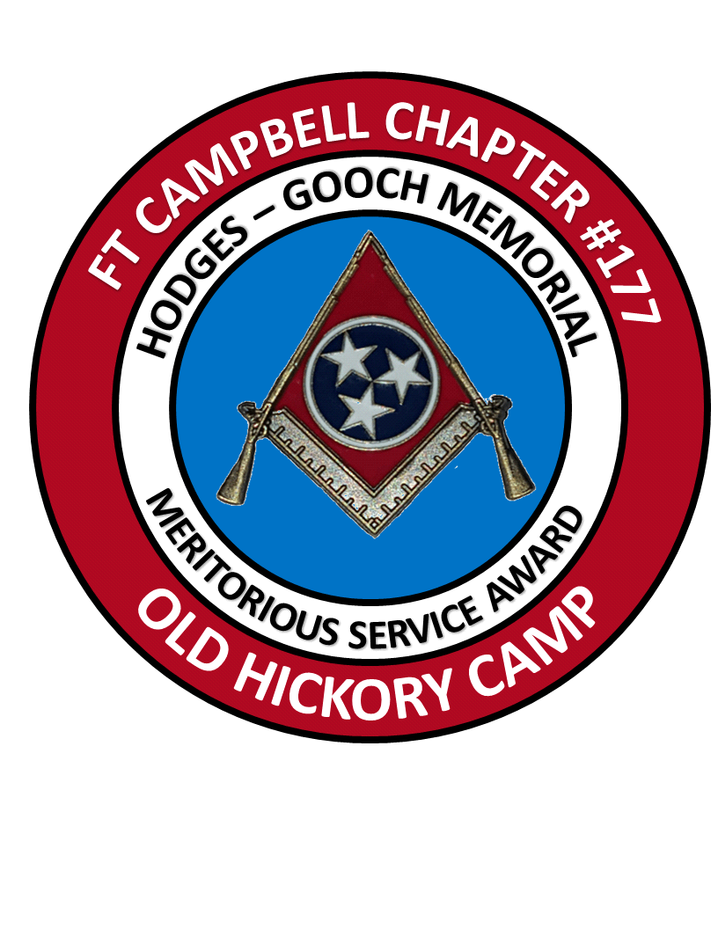This award will be presented at a special dinner in October. Every effort should be made to include all members, spouses, and family members of Robert Gooch and Jere Hodges. The award recipient will receive an Award certificate and a patch created especially for this award.
Appendix B
SUBJ: BENNY DEFFENDOLL DISTINGUISHED SERVICE AWARD
Introduction:
The Benny Deffendoll Distinguished Service Award is presented in recognition of distinguished service to a member recognized by the members of Ft Campbell Chapter # 177, National Sojourners, Inc. and Old Hickory Camp, Heroes of ‘76. The award is named in memory of Br Benny Deffendoll, an Old Hickory Camp Past Commander, who served as an inspiration to the members of our Order for many years.

Criteria:
The award is presented to recognize distinguished service over a sustained period. Nominees should have been members of Ft Campbell Chapter #177 Old Hickory Camp for no less than 1 year. The nomination should provide clear and concise justification as to why an impact award is warranted. Criteria for consideration should include, but are not limited to:
- Outstanding service to the Camp, to include presentations of National Sojourner and Heroes of ‘76 ritual portions at Chapter and Camp meetings and inductions into the Order.
- Outstanding service to the Ft Campbell Chapter #177 National Sojourners as determined by recognition of district or Grand lodge or special recognition by individual lodges.
- Patriotic activities. These can include those performed with the chapter and camp and other activities of Americanism and Bridge of Light presentations.
- Having served in an elected leadership position in both Chapter and Camp
- Service to the community, state and nation, exclusive of the fraternity and chapter.
Award Period:
Nominations for the Service Award should be submitted to the Award chairman no later than the August meeting.

Award Presentation:
This award will be presented at a special dinner in October. Every effort should be made to include all members, spouses, and family members of Br Benny Deffendoll. The award recipient will receive a displayed Old Glory and Bennington Flag; and an Award Certificate.

